Katie Kouril
Module 3.2 Assignment
CSD310 Database Development and Use
December 21, 2025
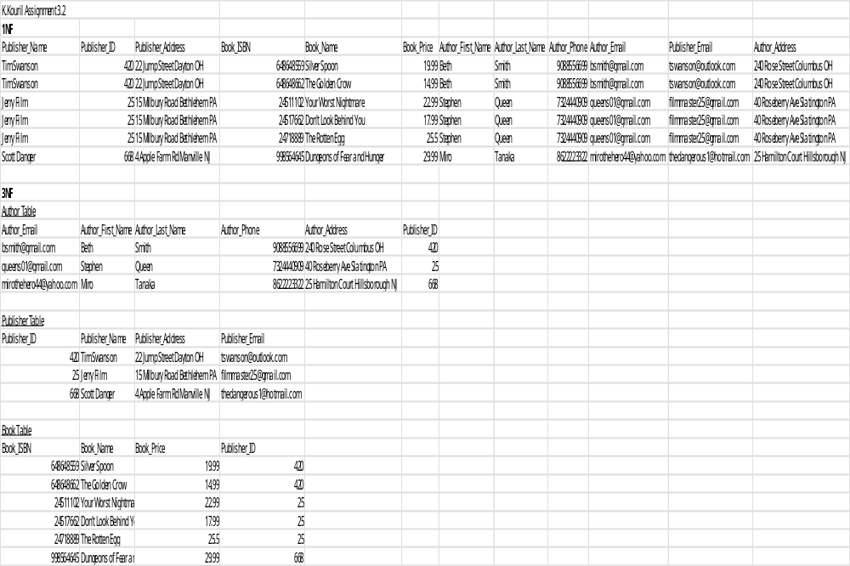

The scaling on inserting the object is too small to read, below is a link to the excel sheet.
Kouril-Assignment 3.2.xlsx

